EKS cluster creation

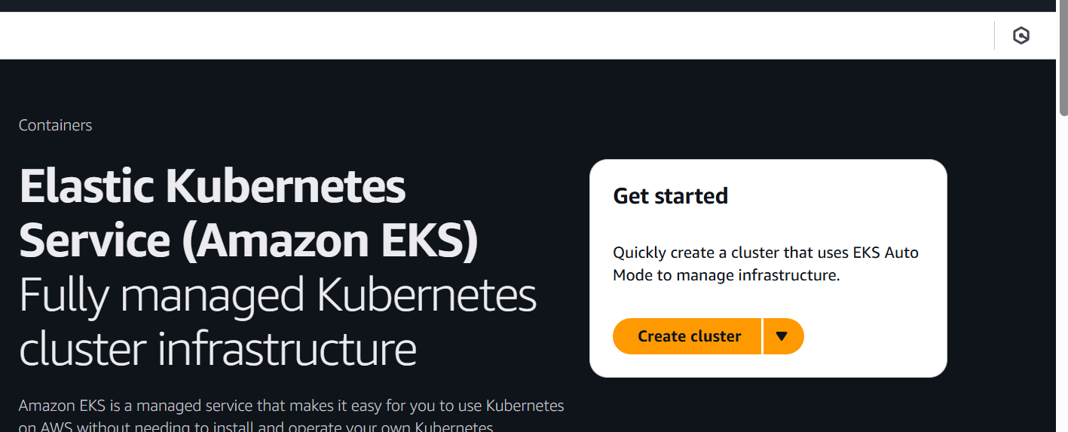

Select auto configuration

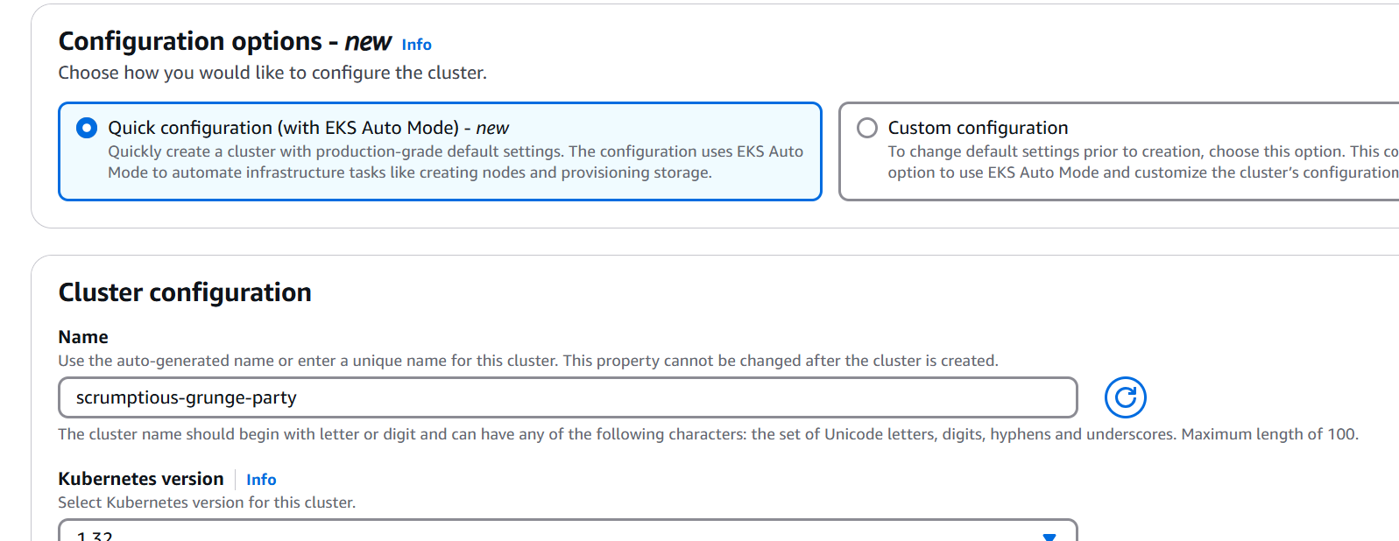

Click on recommended role

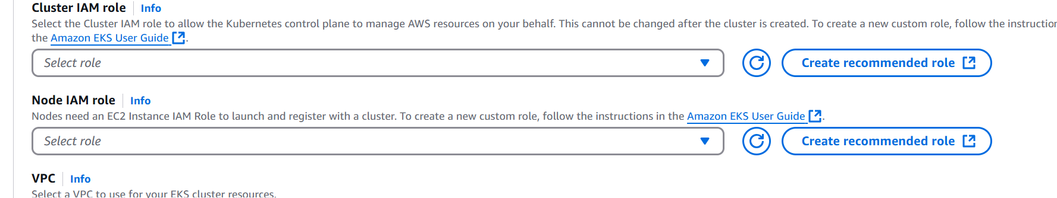

Create default auto role

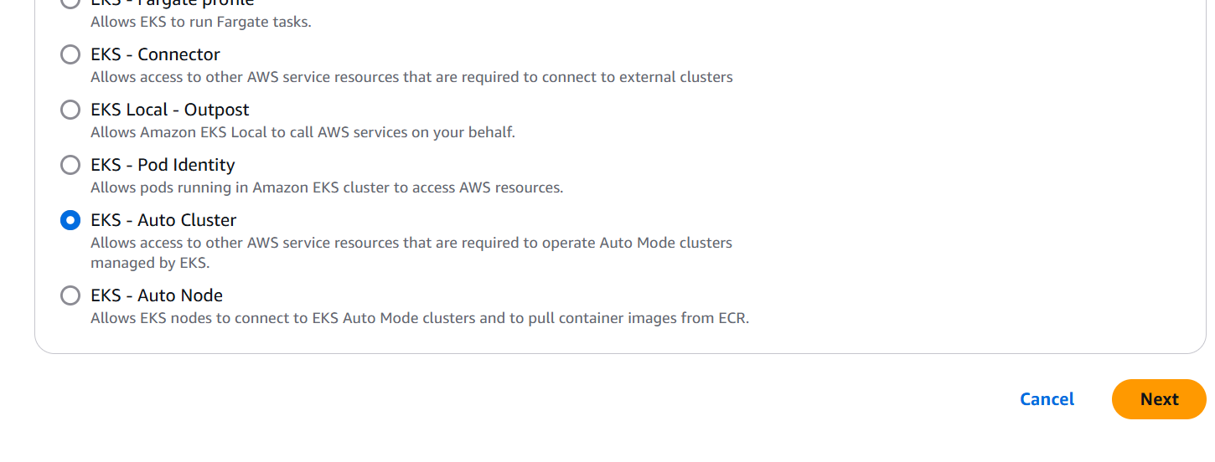

Similar way create Node IAM role

Select both the roles and click on create

Setup aws cli and kubectl in your linux vm

1. Run the following command to start the configuration process:

aws configure

2. You will be prompted to enter the following information:

- AWS Access Key ID: Enter the Access Key ID for your AWS account.

- AWS Secret Access Key: Enter the Secret Access Key corresponding to the Access Key ID.

- Default region name: Specify the AWS region you want to use (e.g., `us-west-2`).

- Default output format: Press Enter to use the default value (`json`).

**Setup kubectl**

1. Download kubectl version 1.32  
   b. Grant execution permissions to kubectl executable  
   c. Move kubectl onto /usr/local/bin  
   d. Test that your kubectl installation was successful

curl -O <https://s3.us-west-2.amazonaws.com/amazon-eks/1.32.0/2024-12-20/bin/linux/amd64/kubectl>

chmod +x kubectl

Node Group Creation

-. In the "Compute" section, click on "Add node group."

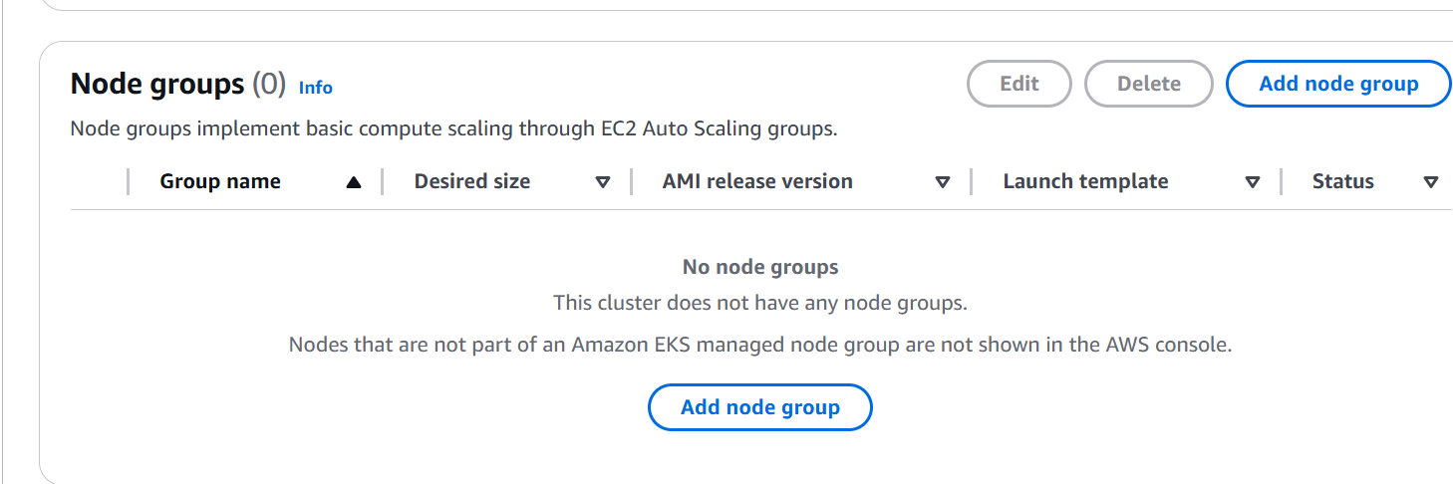

/. Choose the AMI (default), instance type (e.g., t3.medium), and the number of nodes=1.

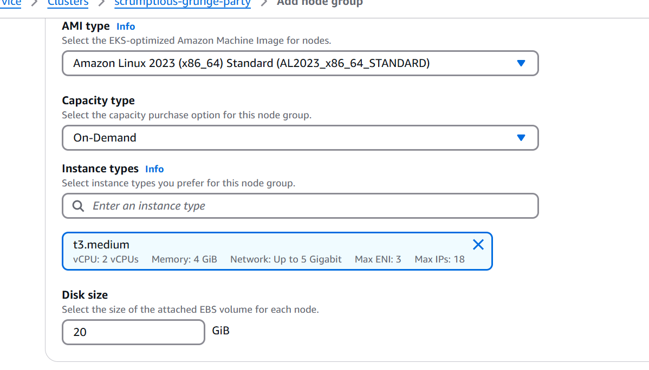

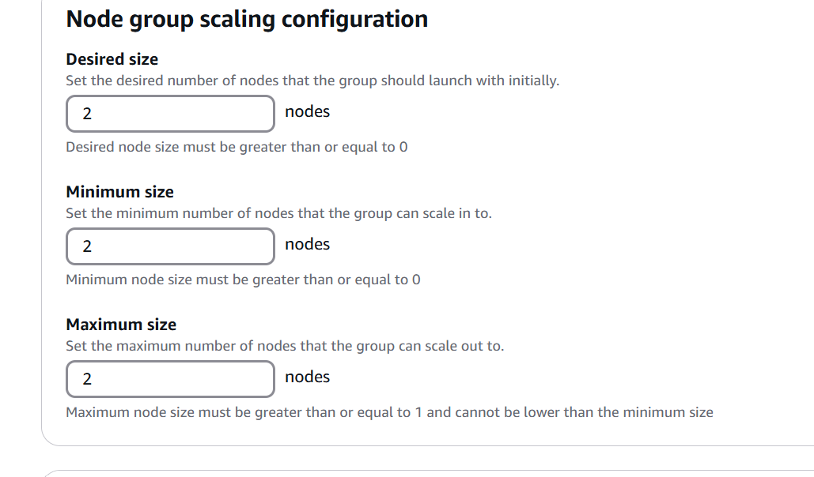

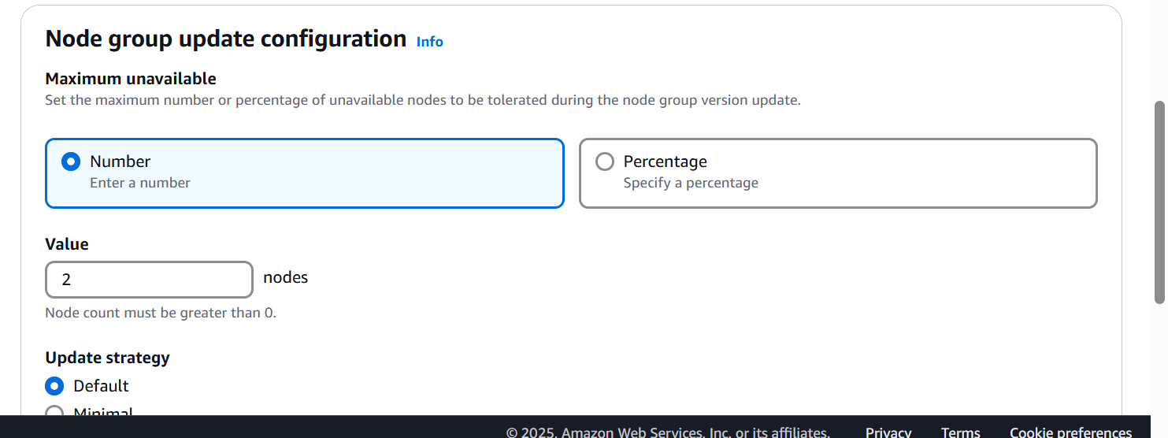

Click on create

aws eks update-kubeconfig --region <region> --name <cluster_name>

